Task 2

2.1

alert tcp any any <> any 80 (msg:"outbound"; sid:100003; rev:1;)

alert tcp any 80 <> any any (msg:"inbound"; sid:100004; rev:2;)

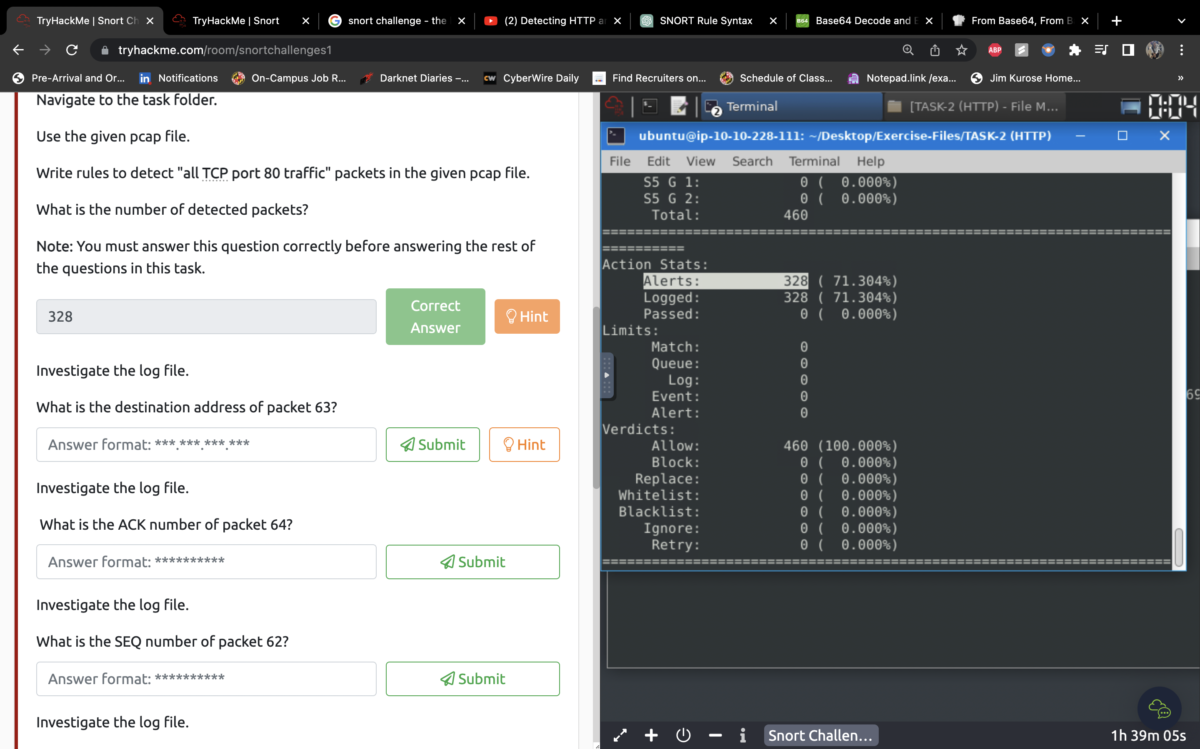

2.2

sudo snort -r snort.log.1686960592 -n 63

(log file name will vary depending on you file name)

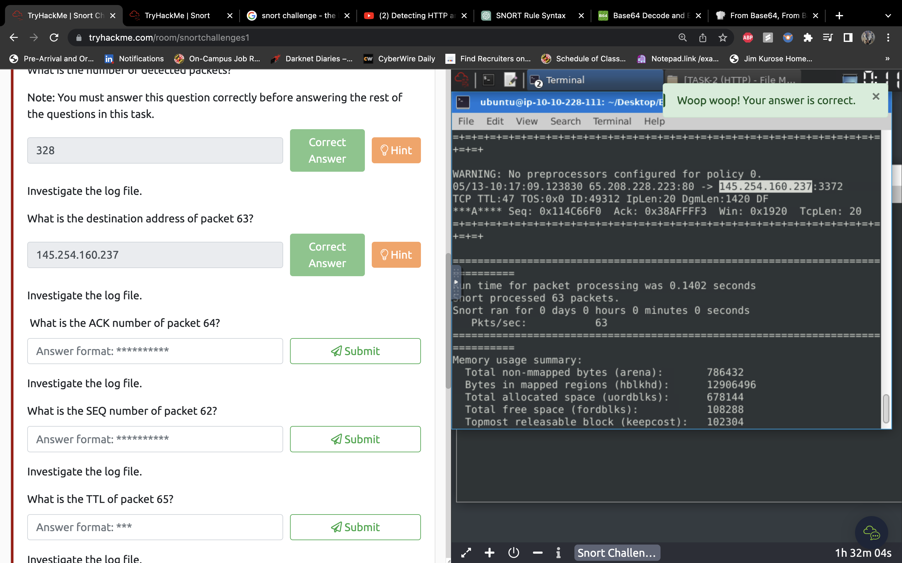

2.3

sudo snort -r snort.log.1686960592 -n 64

(log file name will vary depending on you file name)

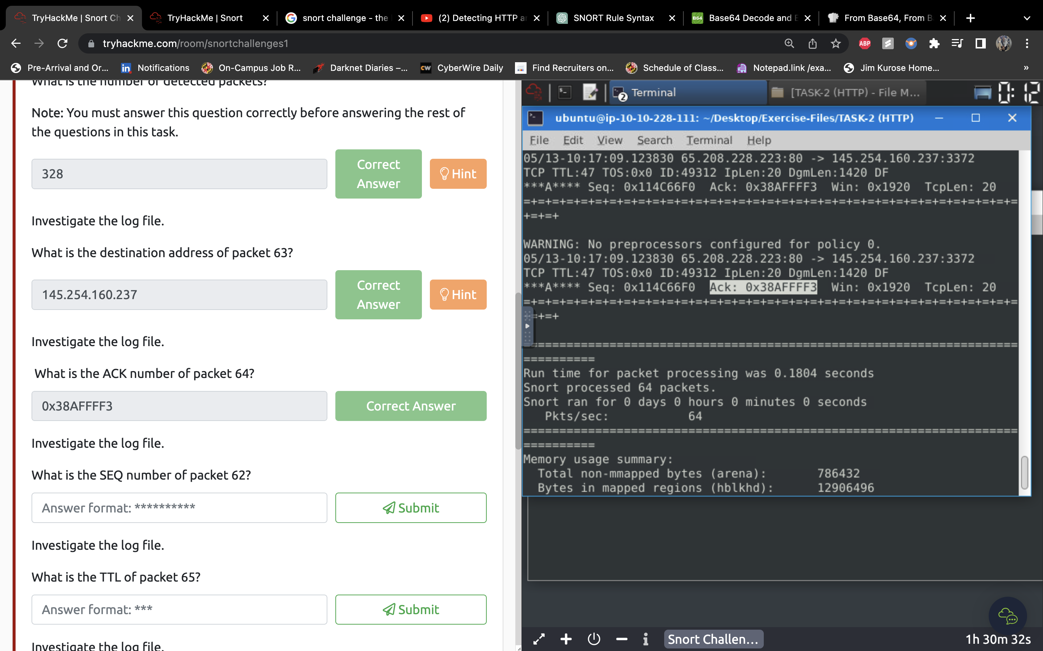

2.4

sudo snort -r snort.log.1686960592 -n 62

(log file name will vary depending on you file name)

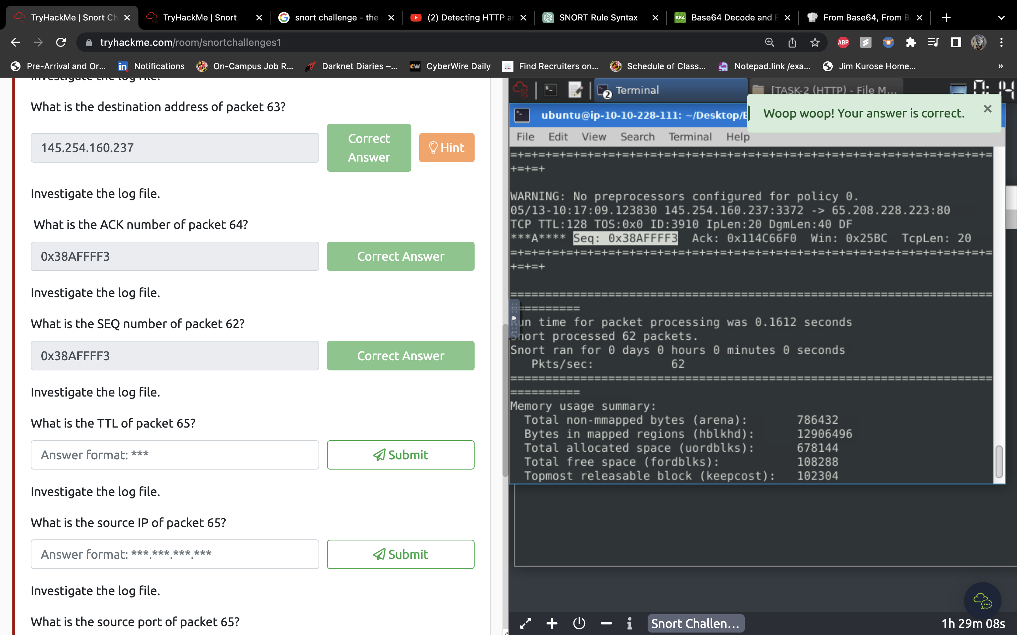

2.5

sudo snort -r snort.log.1686960592 -n 65

(log file name will vary depending on your file name)

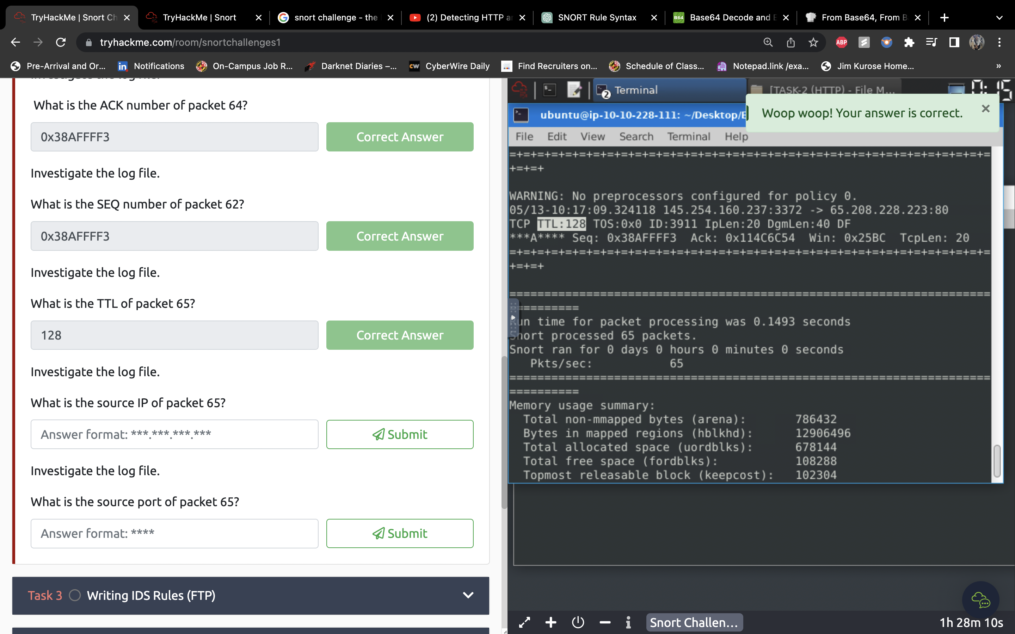

2.6

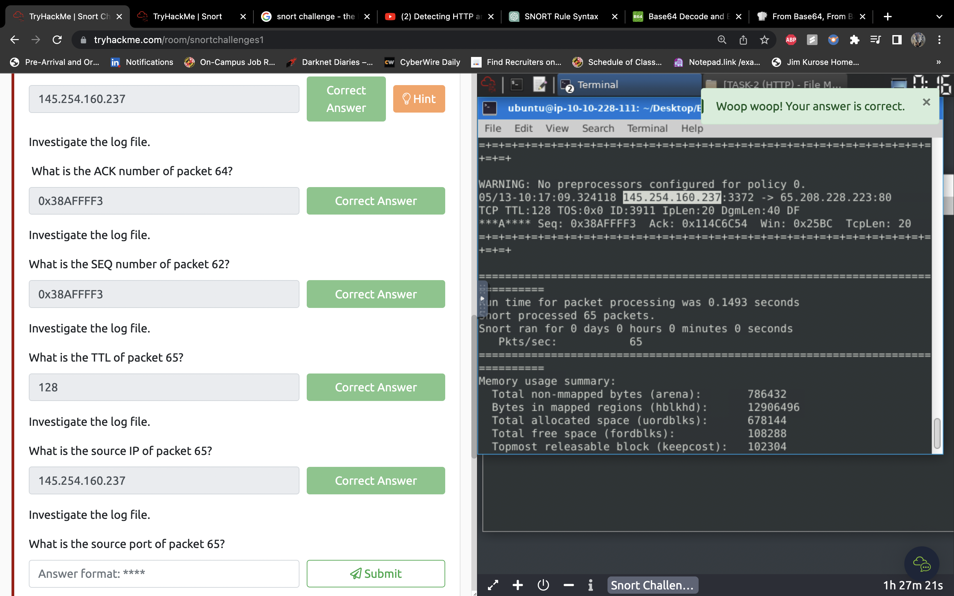

2.7



